**DAILY ONLINE ACTIVITIES SUMMARY**

|  |  |  |  |  |  |  |
| --- | --- | --- | --- | --- | --- | --- |
| **Date:** | 03-06-2020 | | | **Name:** | Gudugunti Anirudh | |
| **Sem & Sec** | IV - A | | | **USN:** | 4AL18CS023 | |
| **Online Test Summary** | | | | | | |
| **Subject** | | Object oriented concepts | | | | |
| **Max. Marks** | | 30 | | **Score** | 16 | |
| **Certification Course Summary** | | | | | | |
| **Course** | Python in ML | | | | | |
| **Certificate Provider** | | | Great learning academy | **Duration:2 hrs** | | **2 hrs** |
| **Coding Challenges** | | | | | | |
| **Problem Statement: :** 1. program to find Last Digit of a^b  2. Largest of two possible digit swaps | | | | | | |
| **Status:** completed | | | | | | |
| **Uploaded the report in Github** | | | | yes | | |
| **If yes Repository name** | | | | https://github.com/alvas-education-foundation/anirudh_gudugunti/tree/master/daily_progress | | |
| **Uploaded the report in slack** | | | | yes | | |

**Online Test Details**: The online test was from module 2 and 3 which was about introduction to java, classes, inheritance and exception handling. There were 30 questions and the duration was 45 minutes. The questions were optimal and were easy. The score that I got in the test is 16/30.

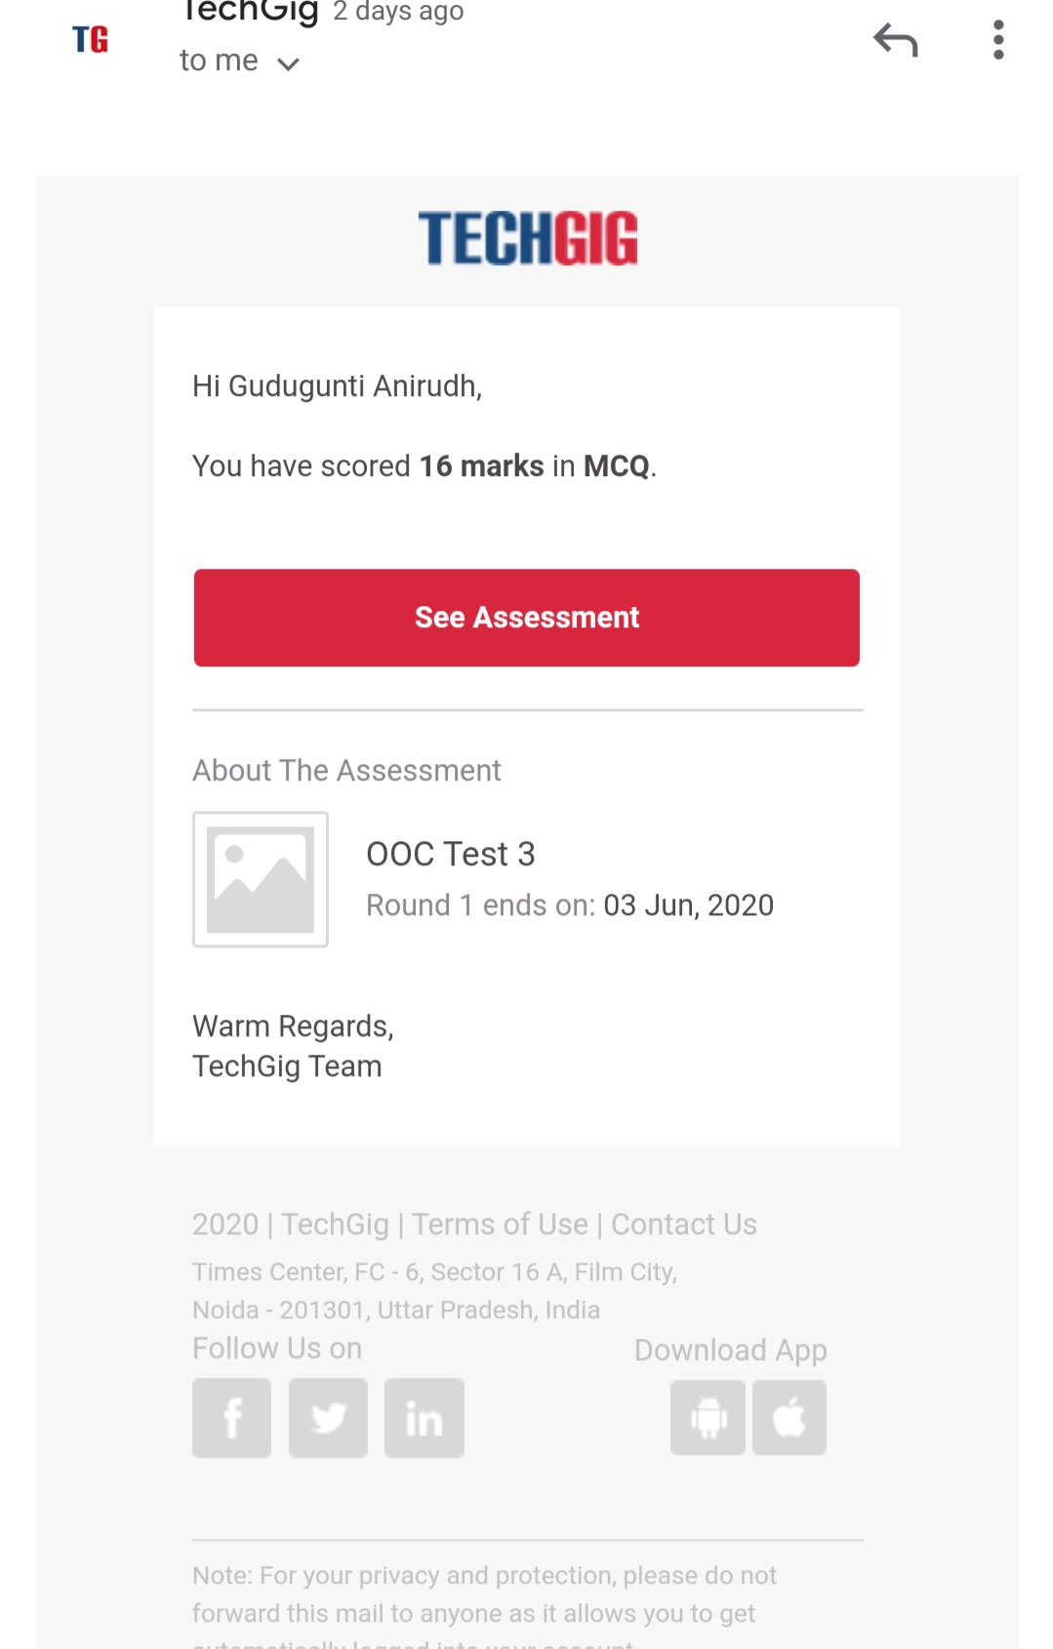

Certification Course Details:

**1. Introduction to user defined functions in python 3.x.**

**2. Detailed instructions on functions in python.**

**3. Worked out examples of functions in python 3.x**

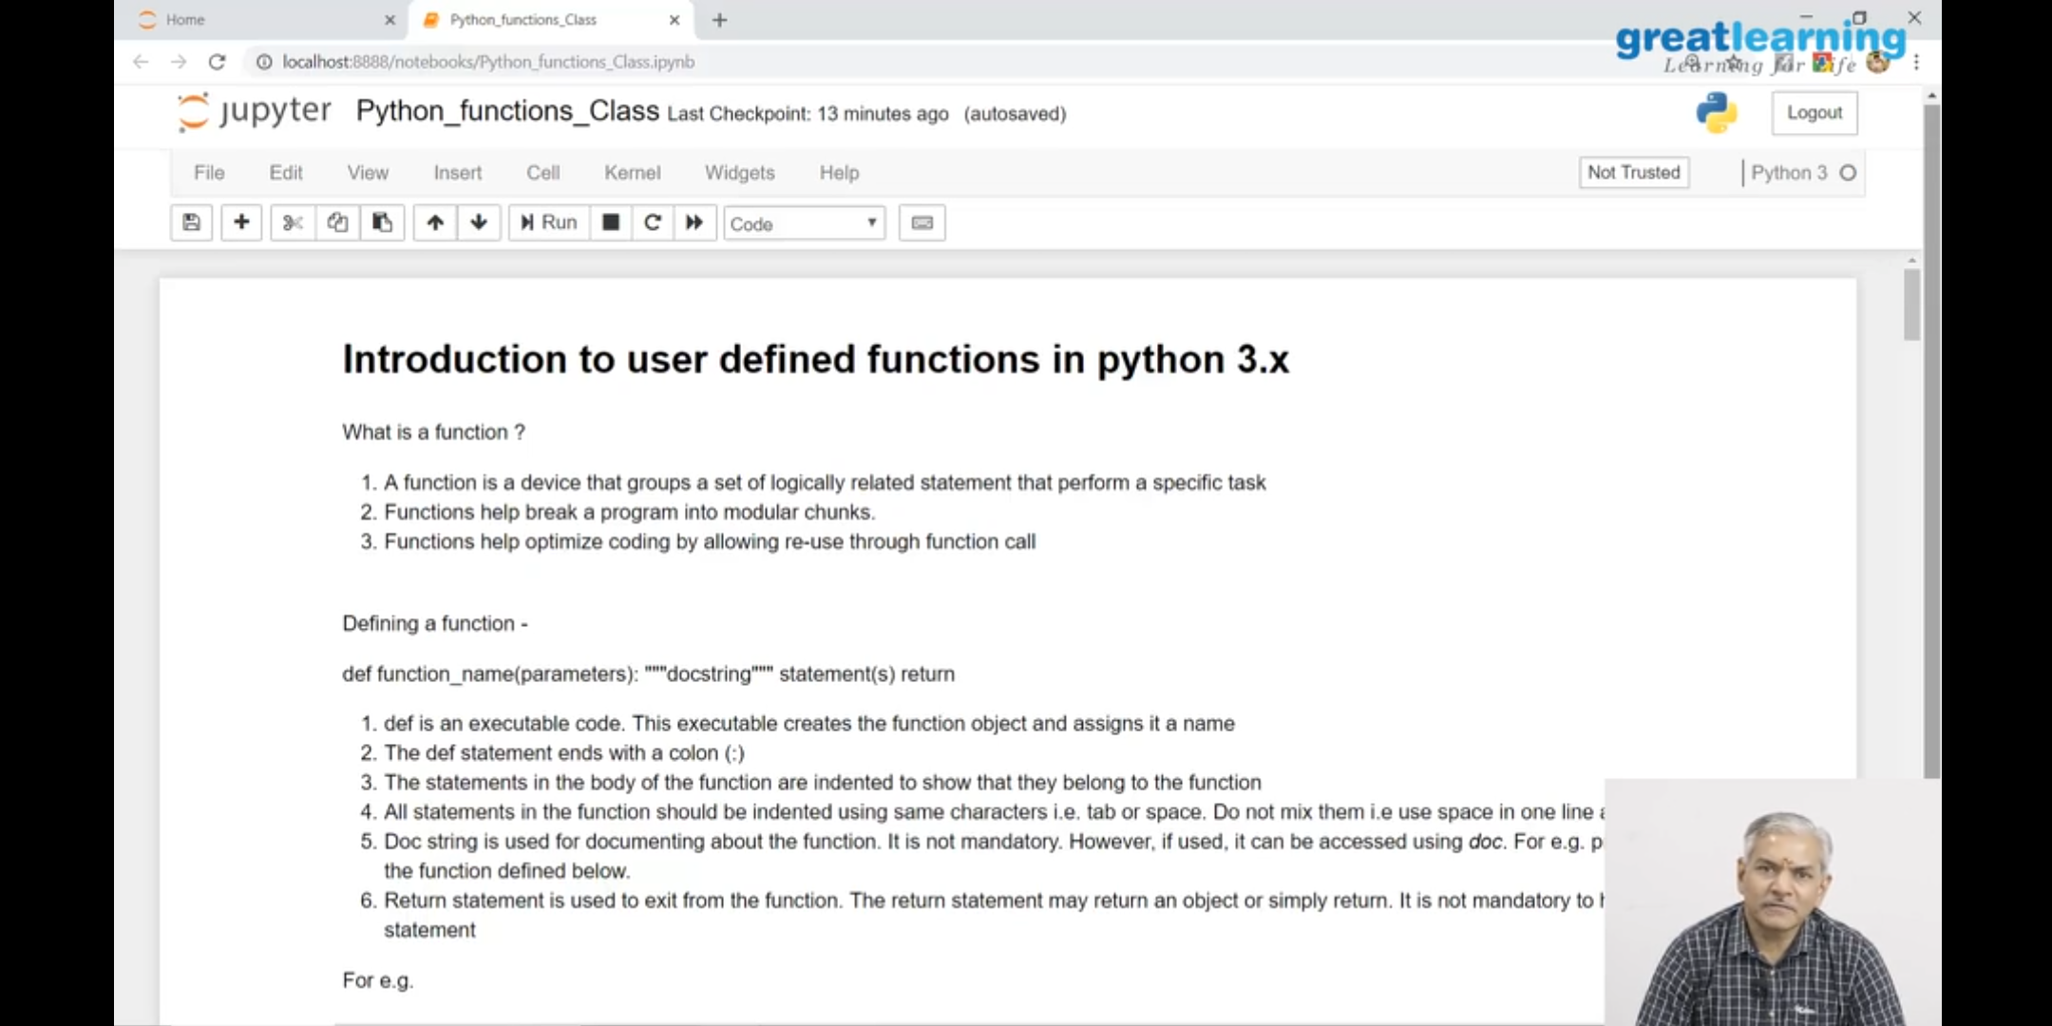

Coding Challenges Details:

Problem 1: (using Java) program to find Last Digit of a^b (a to the power b) for Large Numbers.

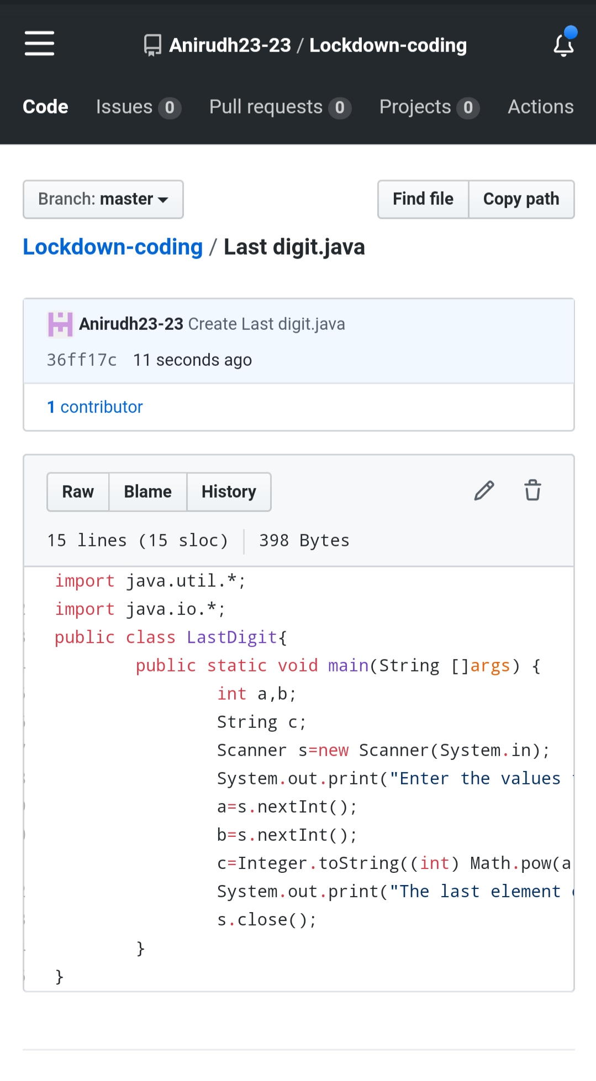

Problem 2: (using C++) Write a function that takes a two-digit number and determines if it's the largest of two possible digit swaps.